School of Information Technology and Data Science

OCTO: Software Engineer
Design and Manipulate Databases (DEMD)
SAQA Qualification ID | 119458
Intake / year | 2-2025
Assessment Name | Summative Assessment
Module NQF Level | 5
Credits | 5
Open date and time | 03 October 2025  - Section B: 17:15
Close date and time | 03 October 2025  - Section B: 20:15
Assessment Total Marks | 100 (50% of total mark percentage)
Pass percentage | 65%
Lecturer Information
Lecturer | Thaveshan Govender
Lecturer E-mail | thaveshang@aie.ac

IMPORTANT NOTICE
Before submitting your assessment, please ensure that it is signed and that all your personal details are accurately filled in the designated space below (Section in red). Work will not be accepted unless the required sections below are fully completed prior to submission, resulting in a 0% grade for this assessment.

The signature must be your valid handwritten signature and NOT your name and surname typed in the space provided.

Student Number:
Student name and surname: |  | Date:
Student cell phone number:
Student Signature:
Lecturer name and surname: | Thaveshan Govender | Date:
Lecturer Signature: | 
Assessor name and surname: |  | Date:
Assessor Signature:
Moderator name and surname: |  | Date:
Moderator Signature:

Instructions to Candidates
- Read each question carefully.
- You must answer Section B below the space provided named “STUDENTANSWER”. Once completed, the answer sheet, with your answers, must be converted to PDF and uploaded to the student portal. Make sure that all additional information is uploaded in a single Zipped folder.
- QCTO students who achieve between 55-64% may have a further submission opportunity, subject to the departmental rules.
- NO LATE submissions will be accepted. (System will automatically close when due date and time is reached). If you encounter any difficulty with the student portal, immediately take a screenshot, log a ticket (attention support), and attach your assessment to the ticket.
- You must follow the departmental formatting guidelines.
- You must write your name, surname, and student number on your script. A failure to do so will result in your script not being marked.
- By submitting your answer sheet for marking, you declare the following:
  - You are familiar with the AIE’s policies on academic dishonesty and plagiarism;
  - Your submitted is your own original work. Where you have made use of someone else’s work, you have duly referenced such work making using of the APA style of referencing;
  - You have not allowed, and will not allow any other student to copy your work; and
  - You did not copy the work of another student.
- Students that are dishonest will be subjected to disciplinary procedures.

Assessment Objective/s:
The Formative assessment will cover the following assessment topics:

No | PM number | PS Description
 | PM-02-PS01 | Design a database
 | PM-02-PS02 | Manipulate data in the database

Scope:
This module is crafted to offer you a unique opportunity to immerse yourself in the activities related to system design, moving beyond theoretical knowledge to the practical application of designing effective and efficient systems. It aims to equip you with the skills necessary to navigate the complexities of system design, from the initial problem definition to the final design solution.

Technical Aspects:
Please verify that all pages are included when downloading this assessment by checking the page numbers at the bottom of the document.
Ensure the following font and size is used in this assessment
- Font: Arial
- Size: 12
- Font colour: Black
- Ensure clear and adequate screenshots are taken where requested
Save and upload the report as a .PDF (No backgrounds) with the following naming convention:
- StudentName_ StudentSurname _Student no_ModuleCode_SA1

Mark allocation for report
See Mark allocation sheet below

Scenario:
You have been appointed as the Junior Database Developer for QuickCart, a growing online retail company. The company has requested a new backend database system to manage its inventory, customer records, and sales transactions for its various products. Once the database is designed, the next objective is to manipulate the data using SQL for reporting and operational purposes.

Use the “PM02_OnlineRetail_Database.xlsx” excel as a reference to complete questns below.

Question 1 (20)
PM No | PS No | PS Description
02 | 01 | Design a database

 | Create a Data Model  - Design an ER diagram using information from the “PM02_OnlineRetail_Database.xlsx” excel spreadsheet.  - Identify key attributes and data types.  - Indicate primary and foreign keys. | [10]
 | ANSWER: (Upload screenshot if necessary)
 | Construct Tables from the ER diagram  - Translate the diagram into SQL CREATE TABLE statements.  - Include appropriate data types and constraints. | [15]
 | ANSWER: (Upload screenshot if necessary)
 | Define Relationships Between Tables  - Implement 1:1, 1:M or M:M relationships between your tables.  - Show the following in your design:  - Relationship design  - Constraints  - Cardinality explanation | [15]
 | ANSWER: (Upload screenshot if necessary)
 | Link Database to a Basic Application  - Create a simple front-end (mock-up or actual UI) that interacts with the database.  - Demonstrate adding, viewing, or modifying records.  Use the following UI as guidance:  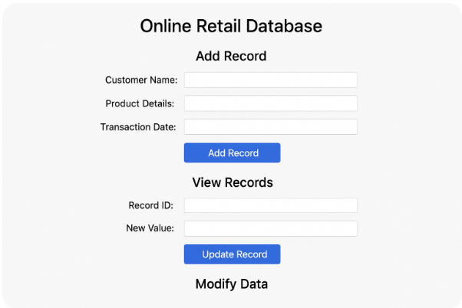 | [10]
 | ANSWER: (Upload screenshot if necessary)

Question 2 (50)
PM No | PS No | PS Description
02 | 02 | Manipulate data in the database

Appropriate SQL code must be used here in the SQL environment.

 | Select Data from Tables  - Query all customers who made purchases in the last month.  - List available products in stock with quantity > 10. | [10]
 | ANSWER: (Upload screenshot if necessary)
 | Insert Data into Tables  - Add a new customer and product.  - Insert a new transaction record involving both. | [10]
 | ANSWER: (Upload screenshot if necessary)
 | Delete Data from Tables  - Remove discontinued product.  - Demonstrate cascade/delete protection logic. | [10]
 | ANSWER: (Upload screenshot if necessary)
 | Update Data in Tables  - Update stock levels post-transaction.  - Modify a customer’s contact details. | [10]
 | ANSWER: (Upload screenshot if necessary)
 | Join Tables Together using “INNERJOIN”  - Display all transactions with customer names and product names. | [10]
 | ANSWER: (Upload screenshot if necessary)

Mark allocation for student
Question | Maximum Mark | Learner mark
Question 1.a | 10
Question 1.b | 15
Question 1.c | 15
Question 1.d | 10
Question 2.a | 10
Question 2.b | 10
Question 2.c | 10
Question 2.d | 10
Question 2.e | 10
Total: | 75

STUDENT ASSESSMENT FEEDBACK
Qualification Name: | OCTO: Software Engineer
Qualification SAQA Number: | 119458
Subject Name: | Design and Manipulate Databases
Subject Code: | DEMD
Assessment Name: | Summative Assessment
Assessment Code: | DEMD_SA

Assessment Decision | Competent |  | Not yet competent

Feedback report | 1st Attempt |  | 2nd Attempt
Feedback report | C | NYC | C | NYC
Practical module/Practical skill
PM02
PS01
PS02

General feedback to learner
Supply comprehensive feedback why learner is found NYC

